11. Easterly Wave Genesis Experiment (GENEX)

Principal Investigator(s): Ghassan Alaka (Lead), Jason Dunion, Alan Brammer (U. Albany), Chris Thorncroft (U. Albany), Mark Boothe (NPS), Yuan-Ming Cheng (U. Albany)

Mission Description: Sample the wind, temperature and moisture fields in the environment ahead and/or within a disturbance that has the potential to develop into a tropical cyclone (i.e. “invest”).

G-IV Module 1
What to Target: Sample the environment to the west of an easterly wave, especially if dry air is detected in that region.
When to Target: Sample when easterly wave is forecast to develop in reliable computer models or is showing signs of development in observations. Sample when easterly wave is located at or west of 35°W (to be within range of G-IV).
Pattern: Lawnmower, rotated 90° for N-S orientation. Pattern should be centered to the west of an advancing tropical wave.

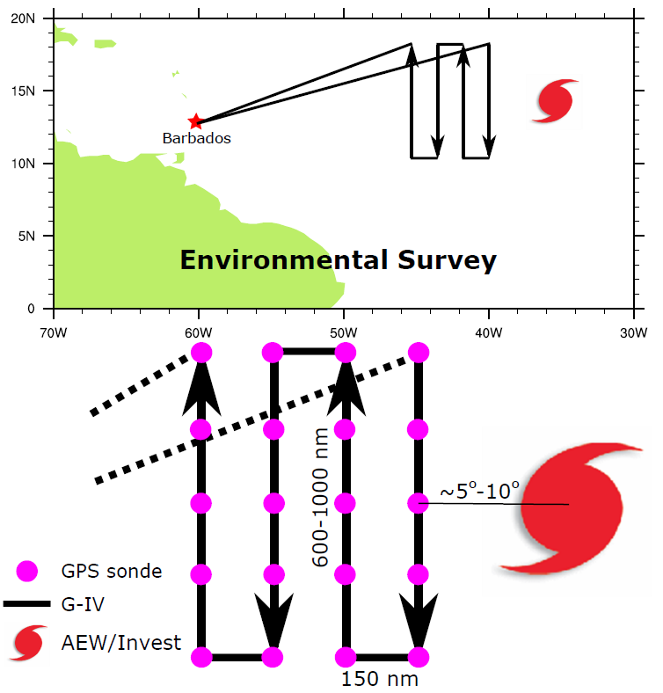

Flight altitude: 40-45 kft
Leg length or radii: Long Legs = 600-1000 n mi, Short Legs = 150 n mi
Estimated in-pattern flight duration: 3 – 4.5 hrs per box
Expendable distribution: ~150 n mi between dropwindsondes. ~10 drops per box
Instrumentation Notes: Use TDR defaults. Use straight flight legs as safety permits.

G-IV Module 2A
What to Target: Sample the environment in and around an easterly wave that is within G-IV range, especially if the wave is expected to develop into a tropical cyclone.
When to Target: Sample when easterly wave is within G-IV range (west of ~40°W) and is forecast to develop in reliable computer models or is showing signs of development in observations.
Pattern: G-IV Circumnavigation (hexagon), especially if no low-level center is discernible panel). To fit within time constraints, pattern should be modified by removing the middle circle.
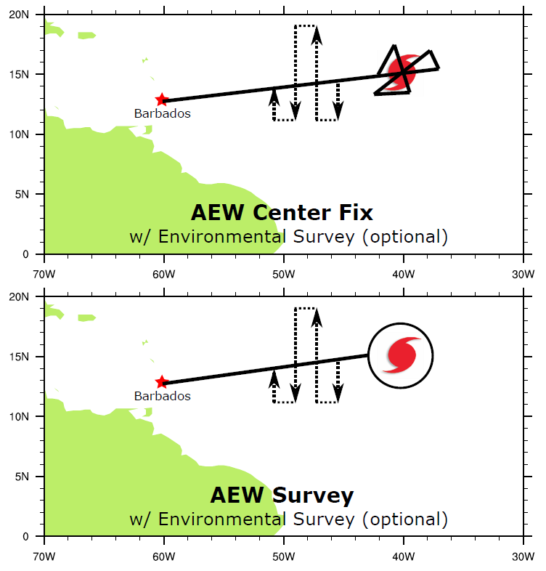
Flight altitude: 40-45 kft
Leg length or radii: Outer circle = 150 n mi. Inner circle = 60 n mi
Estimated in-pattern flight duration: 3 hrs
Expendable distribution: 12 dropsondes, although less may be used to conserve resources.
Instrumentation Notes: Use TDR defaults. Use straight flight legs as safety permits.

G-IV Module 2B
What to Target: Sample the environment in and around an easterly wave, especially if the wave is expected to develop into a tropical cyclone.
When to Target: Sample when easterly wave is within G-IV range (west of ~40°W) and is forecast to develop in reliable computer models or is showing signs of development in observations.
Pattern: Butterfly, especially if easterly wave “center” is clearly discernable.

Flight altitude: 40-45 kft
Leg length or radii: Standard - 105 n mi legs
Estimated in-pattern flight duration: Standard - 2 hrs
Expendable distribution: Standard - 15 dropsondes, although fewer may be used
Instrumentation Notes: Use TDR defaults. Use straight flight legs as safety permits.

P-3 Module 2
What to Target: Sample the environment in and around an easterly wave, especially if the wave is expected to develop into a tropical cyclone.
When to Target: Sample when easterly wave is forecast to develop in reliable computer models or is showing signs of development in observations. Sample when easterly wave is located at or west of 35°W (to be within range of G-IV).
Pattern: Butterfly, especially if easterly wave “center” is clearly discernable (see top panel).
Flight altitude: 10-20 kft
Leg length or radii: Standard - 105 n mi legs
Estimated in-pattern flight duration: Standard - 3:25 hrs
Expendable distribution: Standard - 15 dropsondes, although fewer may be used
Instrumentation Notes: Use TDR defaults. Use straight flight legs as safety permits.

