3. Offshore Wind Module

Principal Investigator(s): Shirley Murillo and Bachir Annane

Mission Description: If there is a TC over or near the vicinity of the offshore wind farm lease areas and there are ongoing missions we request to fly over the lease areas and drop sondes in a 2-4 km interval. This can be executed by either the P3 or the G-IV.

P-3/G-IV Module 1
What to Target: Sample the TC as it makes landfall.
When to Target: The main target is to fly over the wind lease area.
Pattern: Fly a straight leg over the wind farm lease area and launch dropsondes in a 2-4 km interval. The leg can be parallel to the coast line.

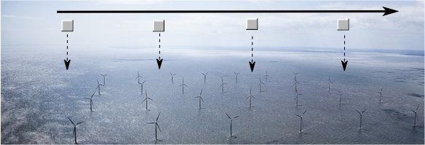

Flight altitude: Standard P3/G-IV altitude.
Leg length or radii: The length of the legs is not specific. The flight leg or a portion of the leg should be over the wind lease area.
Estimated in-pattern flight duration: 10 mins
Expendable distribution: Drop sondes in a 2-4 km interval over the wind lease area.
Instrumentation Notes: Straight and level leg. Drop sondes over the offshore wind lease areas in a 2-4 km interval. Having the wide-swath radar altimeter on the P3 up and running would be ideal but not required.

