Tropical Cyclones in Shear
Paul Reasor, Sim Aberson, Jason Dunion, John Kaplan, Rob Rogers, Eric Uhlhorn, and Jun Zhang

Tropical cyclones form and intensify within the context of a larger-scale environmental flow. The interaction of a tropical cyclone with its environment places an important constraint on the storm’s future intensity. Environmental flow that varies significantly with height in speed or direction, referred to as vertical wind shear, generally limits storm intensity, especially when combined with other environmental factors like low sea-surface temperature and dry air.
The primary goal of this project is to increase understanding of the mechanisms which limit tropical cyclone intensification by sampling a storm with airborne instrumentation at distinct stages of its interaction with shear. Additionally, we will use the dataset to guide improvements in initial conditions and the representation of moist physical processes in hurricane models. These improvements are likely necessary to increase the accuracy of short-term (<24 h) numerical intensity guidance for sheared tropical cyclones.
The flight patterns are designed to optimize the collection of wind, temperature and humidity data in the tropical cyclone environment using the NOAA G-IV aircraft (Fig. 1) and within and immediately outside the region of highest wind speed using the NOAA P-3 aircraft (Fig. 2). Measurements made from the G-IV aircraft help define the storm environment before and during a large increase in shear. Measurements made from the P-3 aircraft document changes in the tropical cyclone flow, particularly near the ocean surface outside the eyewall, as shear attempts to rip apart the storm. We will use these measurements to examine the connection between vertical tilting of the tropical cyclone by shear and cooling/drying of air in the traditionally under-sampled region near the ocean surface outside the eyewall. The flow of this cool, dry air into the eyewall is believed to limit tropical cyclone intensification in shear.
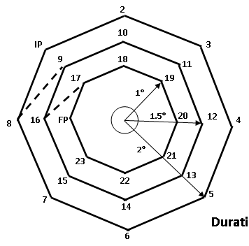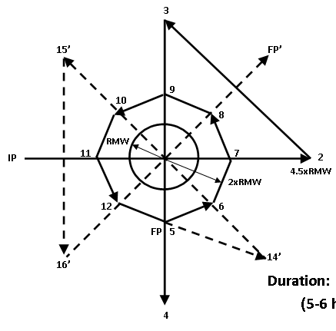
Figure 2: Track of the P-3 aircraft used to sample the tropical cyclone core. RMW = Radius of Maximum Wind.
Figure 1: Track of the G-IV aircraft used to sample the tropical cyclone environment.

