Setting up Alerts in LexisAdvance.com – 2.16.18
This database allows you to search federal legislative work, federal bankruptcy, tax and military courts and many newspaper archives.

To access from the Library home page: http://www.aoml.noaa.gov/general/lib/
E-resources NOAA S. and NOAA N.E. link
Lexis link – this will redirect you to Lexis Advance

Direct link: http://advance.lexis.com

To return to home page click on the "Lexis Advance Research” in the upper left corner.

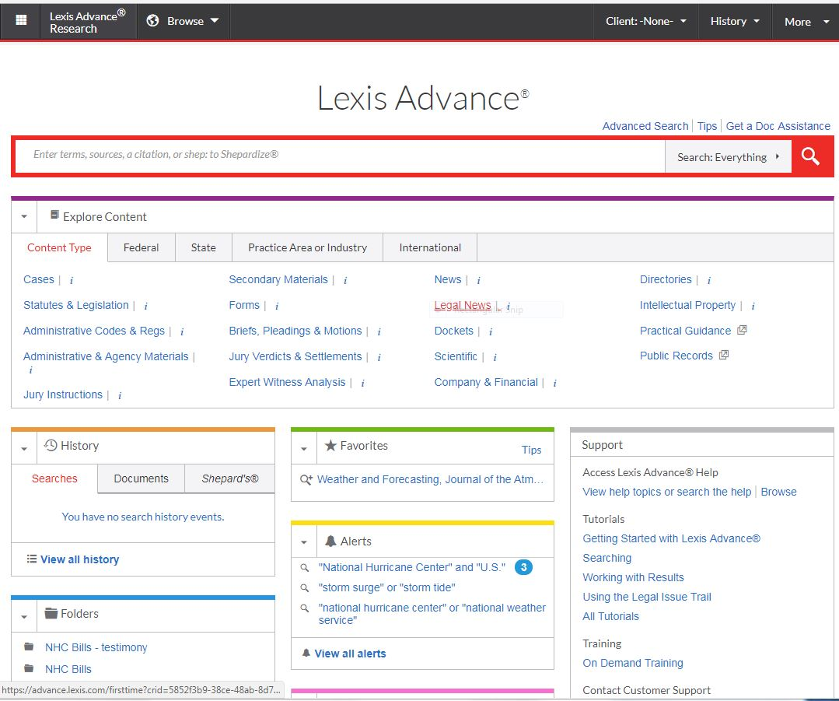
To get articles by topic or author emailed to you, first perform a search, refine your results and then create alerts from there.
There are many different filters and ways to get results. For this example we will look for results for coral reefs. To keep the phrase intact use quotes around it, use AND or OR to combine phrases or search terms.
Enter “Coral Reefs” in the red search box and select ‘Search: Everything” from the dropdown. 6,070 docket returns. In the left menu (see image below) you will see they have the returns separated into categories of dockets, cases, statutes, legislation, secondary materials and more. You can also narrow results by search terms, specific courts, states, time range and other filters.
I’ve kept dockets, and narrowed by state: Florida (4834 results), time range: 2010-2018 (337 results), and source by Florida Circuit Court (246 results). Skimming returns, you’ll notice many are related to real estate and not science. Returning to the left menu, check the ‘case type’ and ‘keywords’ to confirm there are no science related returns.
I changed my search term to ‘coral reef’, narrow by statues and legislation (380 results), ‘bill tracking (14 results) and time span 2010-2018 (6 results). Looking at the top of the filters, highlighted in blue, I see it has retained state: Florida. From the 6 results I checked off the number three result. The menu bar across the top under, ‘Statues and Legislation (6) allows you to create a folder, email it, print, change settings, download or send to drop box.

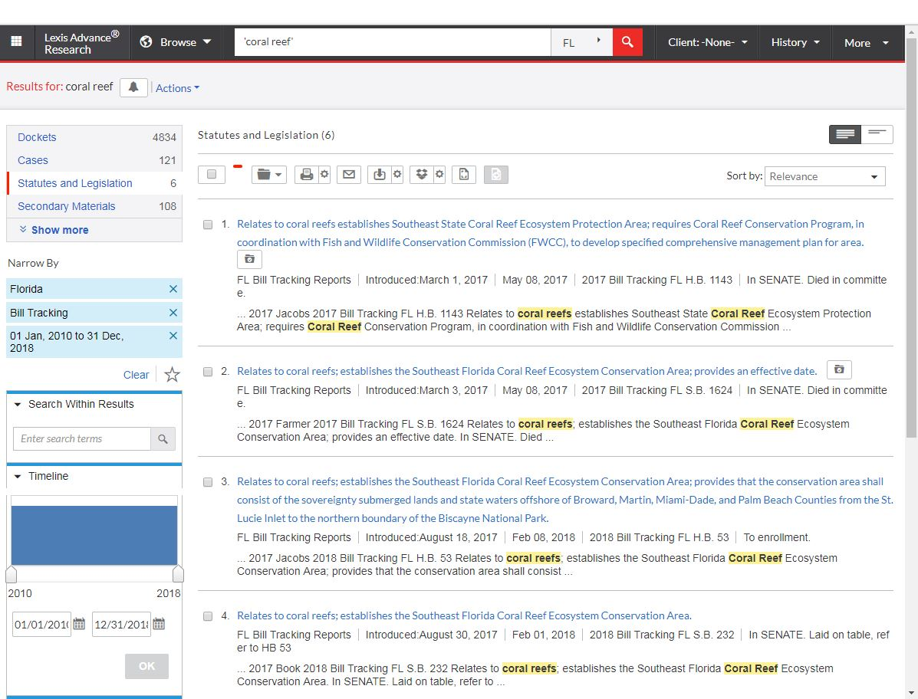
To set this topic as an alert, go to the upper left corner next to ‘Results for: coral reef” and click the bell icon.
A screen comes up with 4 tabs, (image below) overview, monitor, deliver and share. Overview allows you to enter a description, in monitor you select categories including ‘scientific’, deliver tab is where you enter an email address, you add contacts in the share tab. When completed press ‘create’.

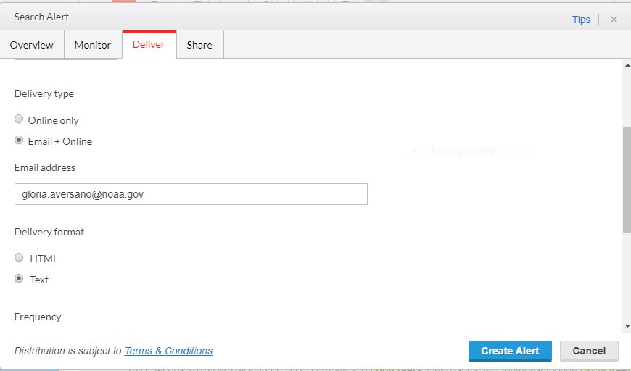
At the top- right of the screen (image above) under the ‘more’ dropdown you can select, Alerts and it will show you all the alerts you’ve already created. You can also view your folders, select ‘live support’ chat services and log out from the ‘more’ tab.

