7.5 Southern Coastal Systems Hypothesis Cluster - Nearshore Faunal Communities
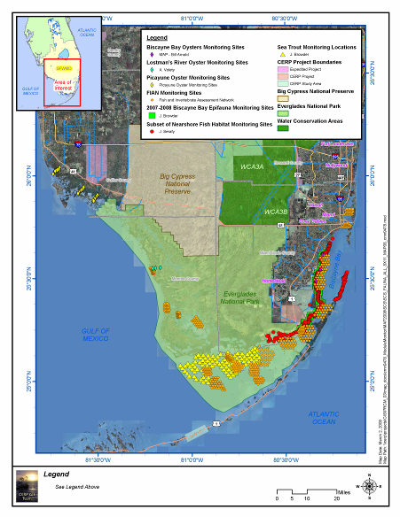
Figure 7.5.X. Multi-species nearshore faunal monitoring network across the Southern Coastal Systems domain.

Abstract
Fish and invertebrate distribution and abundance are key to understanding the effects of CERP on southern coastal ecosystems. Concurrent and complementary faunal monitoring efforts are providing substantial, long-term data that are relevant to assessing a broad suite of hypotheses as they pertain to nearshore faunal community responses to natural and anthropogenic processes.. In the 2009 SSR, the spatio-temporal extent, quantity, and quality of these data for taxa that use the SCS as feeding, nursery and/or primary habitat will be illustrated: gray snapper (Lutjanus griseus), spotted seatrout (Cynoscion nebulosus), and pink shrimp (Farfantepenaeus duorarum). These three species: (1) are among the most ecologically and economically important species in the SCS; and (2) display responses to salinity (and therefore, to changes in freshwater flow) in terms of their distribution and/or abundance. Ongoing fieldwork is also quantifying the abundance, distribution, size-structure, and salinity relationships for various species of mojarras, grunts, killifishes, barracuda, gobies, pipefishes, and caridean shrimps. Furthermore, the designed spatiotemporal overlap of the faunal sampling efforts allow characterization of species assemblages across trophic levels, their variation in space and time, and relationships with habitat.

7.5.2 Background
Patterns of variation in SCS fauna reflect processes that occur within, upstream and offshore of Biscayne Bay, Florida Bay and southwestern Florida coast. As the most downstream component of the Everglades ecosystem, the SCS integrates multiple upstream changes, which ultimately impact the abundance and diversity of its fish and invertebrate communities. These fish and invertebrate communities are of critical importance in coastal food webs and form the basis of several commercial and recreational fishes. Faunal response to restoration is dependent on the magnitude and spatial extent of alteration in several factors that include physical (salinity, turbidity), primary producer (seagrass and phytoplankton) and secondary producer (zooplankton and epibenthic invertebrates) changes. The faunal projects described here provide fishery-independent assessments of the early life stages of several important coastal fishery populations in the SCS. Thus, the data provide indicators of the potential effect of restoration on the coastal fishery populations in south Florida, one of south Florida’s primary economic resources. Moreover, the majority of the public will likely perceive the success of restoration based upon its impact on the SCS and especially fishery resources dependent upon the SCS habitat. This contention is based upon the number of visitors to the SCS coastal waters, specifically to interact with the fauna via fishing, snorkeling and diving, far outnumbering the number of visitors to the wetlands in and adjacent to Everglades National Park. Given the ecological, economic and social importance of the faunal components of the SCS, it is critical that they be incorporated into adaptive management decisions.
Table 1. Southern Coastal Systems Faunal Monitoring Projects. Current naming convention carried over from original contracting negotiations does not convey accurate nature of these complimentary (rather than duplicative) efforts. New names are proposed to resolve perceived problems of overlap.
Current Name of Ongoing SCS Faunal Monitoring | Proposed Re-Name | Comments
Shoreline Fish Community Visual Assessment (NOAA) | Biscayne Bay Mangrove Fish (NOAA) | Three related efforts provide complimentary data in Biscayne Bay
Epibenthic Fauna Adjacent to the South Biscayne Bay Shoreline in Relation to Seagrass, Shoreline Fishes, and Freshwater Change in the CERP/Southern Estuaries Module Domain (NOAA) | Biscayne Bay Alongshore Epifaunal Communities
Documenting Everglades Restoration Impacts on Biscayne Bay's Shallowest Benthic Habitats (NOAA) | Biscayne Bay Nearshore SAV
South Florida Seagrass Fish and Invertebrate Assessment Network (NOAA) | Seagrass Fish and Invertebrate Assessment Network (FIAN, NOAA and USGS) | One project supported by two funding streams.
South Florida Seagrass Fish and Invertebrate Assessment Network (USGS) |  | One project supported by two funding streams.
Juvenile Spotted Seatrout Monitoring in Florida Bay (NOAA) | Florida Bay Juvenile Sportfish (NOAA)
Biscayne Bay Coastal Wetland Fish Communities (NOAA) | Biscayne Bay Freshwater Wetland Fish Communities | Compliments efforts in coastal wetlands of Florida Bay and mangroves of lower southwest coast
South Florida Fish Habitat Assessment Network (FFWC) | South Florida Seagrass Assessment Network (FFWC) | Not faunal monitoring effort, but SAV
Oyster monitoring | Oyster Monitoring

The Biscayne Bay Mangrove Fish Community Assessment has a long time history (1998-present), which is invaluable in determining connections of fish abundance with salinity, and it covers an area that will be the first in Biscayne Bay impacted by changes in water management. This visual survey effort mainly quantifies the juveniles of larger fishes that not adequately sampled by other efforts, including some important sport and commercial fish (e.g., snapper, grunt and snook), found in or near the mangrove zone of Biscayne Bay. This report contains a synopsis of this project; details can be found in Serafy et al. (2009).
The Biscayne Bay Alongshore Epifaunal Project is complementary to the shoreline visual fish survey by quantifying invertebrates and small epifaunal fish species that cannot be sampled by visual means. The Biscayne Bay Alongshore Epifaunal sampling design is integrated with that of the Biscayne Bay Mangrove Fish Community Assessment and the Biscayne Bay Nearshore SAV, allowing for quantification of restoration’s impact on trophic relationships in nearshore Biscayne Bay from primary producers through small forage species to top predators. The invertebrates sampled by this project include two commercially and recreationally important species, pink shrimp and blue crab. The epifaunal community embodies much of the diversity of the nearshore waters of Biscayne Bay, and the Epifaunal Project focuses on community-based performance, directly addressing the restoration objective of reestablishing an estuarine fish and invertebrate community in nearshore South Biscayne Bay. This report contains a synopsis of this project; details can be in Browder et al. (2009).

The Biscayne Bay Nearshore SAV project provides a spatially detailed description of benthic habitat (seagrass, algae, sponges, and soft and hard corals) along the same strip of shoreline covered by the Shoreline Fish Visual Survey and the Alongshore epifaunal Monitoring Project. The three projects are coordinated in their sampling design to provide integrated responses to salinity at three trophic levels. The Habitat Assessment Network monitors the cover and composition of seagrass and other bottom vegetation broadly across the southern estuaries using a tessellated grid design at sites in Biscayne Bay, Florida Bay, and the southwest Florida mangrove coast. Thus, the five faunal projects and the two benthic habitat (SAV) projects complement and build upon one another to provide a strong basis for determining CERP success.
The Seagrass Fish and Invertebrate Network (FIAN) monitors small fish and macroinvertebrates (including pink shrimp), and ties together system-wide faunal response by sampling across Biscayne Bay, Florida Bay, and the southwest Florida coast. FIAN is tightly linked to the South Florida Seagrass Assessment Network (FFWC) in sampling design and locations to allow integration of the data of these complementary projects. The value of the FIAN data is further reinforced by the historic long-term (1984-1991, 1994-2007) sampling in Johnson Key Basin. This report contains a synopsis of this project; details can be found in Browder et al. (2009)

The Florida Bay Juvenile Sportfish Monitoring Project focuses on an important sportfish species, spotted seatrout, but also generates data on other key sportfish species in Florida Bay where visual surveys are impractical due to highly variable water clarity. Thus the Biscayne Bay Mangrove Fish and Florida Bay Juvenile Sportfish Projects fulfill similar roles in their respective systems. The Florida Bay Juvenile Sportfish project has a long time-series with collections beginning in the mid-1980s (before the seagrass die-off occurred in Florida Bay). Moreover, it is the only project specifically quantifying the effect of restoration on economically important sportfish in Florida Bay. This report contains a synopsis of this project; details can be in found in Kelble et al. (2009).

The Biscayne Bay Freshwater Wetland Fish Communities Project monitors the forage fishes of the fresh and brackish marshes that lie upstream of the Biscayne Bay’s mainland shoreline. These wetland fishes are the nutritional basis for wading bird, sportfish and reptile populations in the SCS as they are in the Greater Everglades. Thus the same methods are being applied and data collected for the coastal wetlands of Biscayne Bay, Florida Bay and the mangrove estuaries of the southwest Florida coast. Because wetland fish monitoring is closely tied to stations that continuously measure salinity and depth variation, the effort is well-suited for detecting rapid responses to water flow and depth variation, whether CERP- or naturally-induced. This report contains a synopsis of this project; details can be in found in Lorenz et al. (2009).
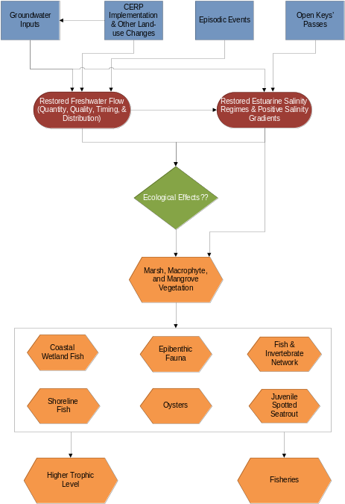

7.5.3 Ecological Hypotheses and Performance Measures

7.5.4 Florida Bay Juvenile Sportfish Monitoring

7.5.4.1 Juvenile Sportfish – Background & Methods
Spotted seatrout, Cynoscion nebulosus, spend their entire life history within Florida Bay. The distribution of juvenile spotted seatrout has been observed to vary in response to salinity conditions (Thayer et al., 1999), making them an ideal indicator to assess Florida Bay’s response to water management changes in the Comprehensive Everglades Restoration Plan (CERP). Monitoring of juvenile spotted seatrout employs a stratified random sampling design focused on the northern half of western and central Florida Bay (Figure ST-1). Sampling takes place from June to November to coincide with the peak of spotted seatrout spawning in Florida Bay. Historically, this sampling was distributed by sub-regional area; however, two recently completed power analyses produced complementary results suggesting the sampling effort should be redistributed. Future sampling effort will distribute samples more equally amongst sub-regions and increase overall sampling effort to enable the capability of detecting at least 20% changes (alpha=0.05; beta=0.80) changes in the frequency per 5-year time block.

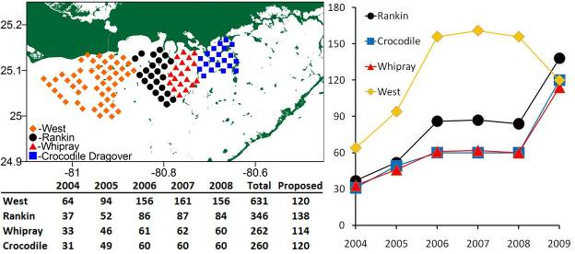
Figure ST-1: Table and figures displaying the spatial and temporal distribution of sampling effort for juvenile spotted seatrout. The map in the upper left displays the location of all potential sampling locations. The line graph on the right displays the temporal sampling distribution in each sub-region and the proposed 2009 sampling effort. The table on the lower left shows the number of stations sampled in each sub-region each year, including the total number of samples collected in MAP thus far and the proposed number of samples for this year.

7.5.4.2 Juvenile Sportfish – Results & Discussion
Juvenile spotted seatrout results obtained thus far display a wide degree of temporal and spatial
variability. The west sub-region appears to support the largest juvenile spotted seatrout population. The frequency of occurrence in the west consistently exceeded 11% each year and was 25.2% for the entire MAP study (2004-2008). Whipray had the next highest frequency of occurrence (22.4%), followed by Rankin (13.2%), and Crocodile Dragover (4.2%) (Fig. ST-2). Overall 2006 had the highest frequency of occurrence and density of juvenile spotted seatrout; whereas 2008 was the lowest with no juvenile spotted seatrout observed in Crocodile Dragover or Rankin and only 1 observed in Whipray. Interestingly, 2008 had the highest mean salinities for all sub-regions (Fig ST-3) and the lowest populations of juvenile spotted seatrout in all sub-regions except the West, strongly suggesting an inverse relationship exists at least at high salinities.

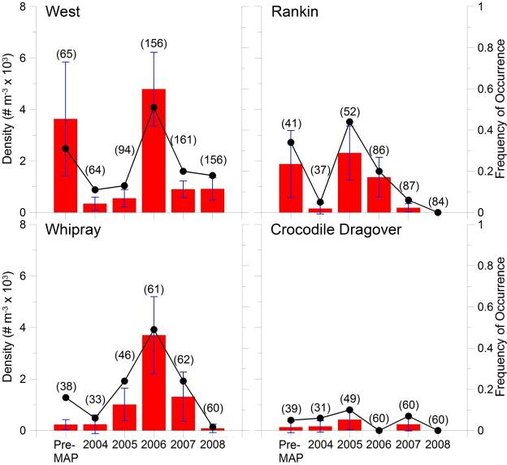
Figure ST-2: Juvenile spotted seatrout density and frequency of occurrence in each of the four sub-regions by year during the MAP study and grouped as one category for all pre-MAP data from 1984-85 and 1994-2001.

Statistical analyses and a general linear model further analyzed the relationship between juvenile spotted seatrout and salinity. The general linear model examined the bay-wide distribution of juvenile spotted seatrout and treated seagrass biomass, temperature, and salinity as categorical independent variables delineated by quartiles. The best GLM model incorporated all 3 variables, including salinity for which an inverse relationship emerged (Fig ST-3). A significant inverse linear relationship between salinity and juvenile spotted seatrout frequency of occurrence was observed in the field data for all of the sub-regions, except the west where there was no significant regression (Fig ST-3). These results suggest that within the central area of Florida Bay the juvenile spotted seatrout population is inversely related to salinity, but this may not be the case in the West region, perhaps due to varying contributions by multiple spawning grounds, thereby confounding salinity effects. Based on our results, we contend that if CERP effectively mitigates hypersalinity in central Florida Bay as the interim goal states, this is likely to increase the population of juvenile spotted seatrout.

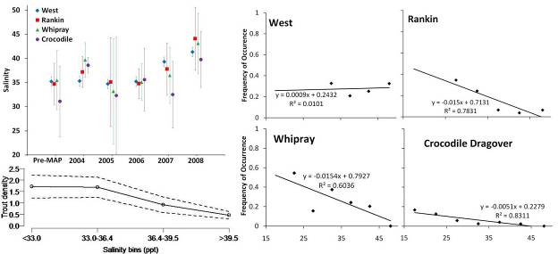
Figure ST-3: Graphs illustrating the dependence of juvenile spotted seatrout on salinity. The top left panel shows the mean and standard deviation for salinity for each year during the study period in each sub-region. The lower left panel displays the relationship between salinity and density of juvenile spotted seatrout calculated by the GLM. The four right panels show the linear relationship between salinity and frequency of occurrence for juvenile spotted seatrout in each sub-region.

Power analyses performed in this and the Biscayne Bay Mangrove Fish project have shown the importance of having an uninterrupted time series for several years (>5) before and after a restoration project impacts (e.g., altered salinity regimes) for optimal detection of faunal responses. This suggests that interruption of these time-series when projects are being undertaken that are likely to affect this ecosystem in the next five years (BBCW, C-111, Mod-waters, etc.) would greatly reduce our ability to evaluate the effect of these projects on SCS fauna and thus increase the chance that the public perceives them as unsuccessful. In conclusion, performance measures based on monitoring the rich resources of the southern coastal system, at the downstream end of the water management system, will provide the ultimate test of restoration success.

7.5.5 Biscayne Bay Mangrove Fish Community Visual Assessment

7.5.5.1 Biscayne Bay Mangrove Fish – Background & Methods
The Biscayne Bay Mangrove Fish project recognizes that CERP-related impacts on coastal systems are likely to be the strongest and most easily discerned along the mangrove-lined shorelines of South Florida’s mainland. The Biscayne Bay Mangrove Fish project builds on a mangrove-fish monitoring effort that had been ongoing for several years. Specifically, southern Biscayne Bay’s shoreline fish community has been monitored visually by the Principal Investigator’s research team twice annually since 1998 (Figure 1). Methods and results after the first two years of monitoring have been published (Serafy et al., 2003). Since then, monitoring has expanded spatially and sampling intensity has increased to: (1) determine pre-CERP variation in selected fish community indices (i.e., fish taxonomic richness and dominance) and taxon-specific abundance metrics (occurrence and density of individual taxa); and (2) examine relationships between nearshore salinity regimes and the composition and structure of the shoreline fish community.

Details of the survey design and field methods are given in Serafy et al. (2003, 2006) and various analyses and results based on these data can be found in Serafy et al. (2007, 2009). Monitoring has focused on the western and eastern margins of southern Biscayne Bay, Card Sound, and Barnes Sound (Figure 1). Sampling is conducted twice annually, during the wet (July to September) and the dry (January to March) seasons. To date, the survey spans 21 consecutive wet-dry seasons (10.5 years) along four shoreline segments. Collected since 2005 are data associated with 20 to 50 belt transects (samples) per annum for each shoreline segment.

Figure 1: Spatial and temporal extent of sampling effort associated with the shoreline fish community visual assessment. Values are numbers of visual transects. Colors correspond to shoreline segments. D=dry season; W= wet season.

7.5.5.2 Biscayne Bay Mangrove Fish - Results and Discussion

Community indices
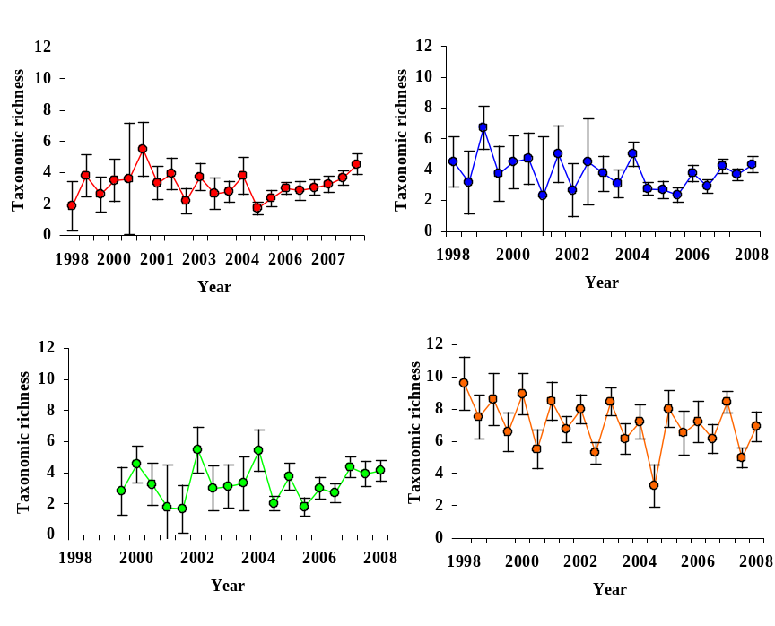
The Biscayne Bay Mangrove Fish project provides a pre-CERP time series of community indices as well as abundance information for a variety of mangrove-fish species. Figure 2 presents the taxonomic richness time series for each shoreline segment. Power analyses (Serafy et al. 2009) indicate allocation of sampling effort is more than adequate for detecting richness changes (20% change, alpha=0.05, beta=0.8) on an annual basis. Trend analyses indicate this community index has been relatively stable for all shoreline segments over the period of record.

Figure 2: Time series plots providing mean fish taxonomic richness along four shoreline segments of the monitoring domain (see Figure 1). Error bars represent 95% confidence intervals.

Taxon-specific abundances
Typically, taxon-specific catch-per-unit-effort and density values are dominated by zero values, which compromise the application of standard parametric statistical procedures. In these cases, analysis of the frequency of occurrence and concentration (i.e., density when present) of individual taxa is powerful from both statistical and ecological standpoints. Two examples of the type of time series data that has been developed for several fish taxa are presented in Figure 3. These plots track temporal variation in gray snapper (Lutjanus griseus) and yellowfin mojarra (Gerres cincereus) abundance along the mainland stratum (segments combined) over the 10.5-yr period of record. Trend analyses indicate that abundance levels of both species have been relatively stable over the period of record. Power analyses indicate that the current sampling design is sufficient to detect a ≤ 40% change (alpha=0.05, beta=0.8) in the occurrences of both species on a season-by-season basis. Detecting change (20%, alpha=0.05, beta=0.8) in the concentrations of both species, however, requires pooling of samples into 5-yr time intervals. Refer to Serafy et al. (2009) for further details.
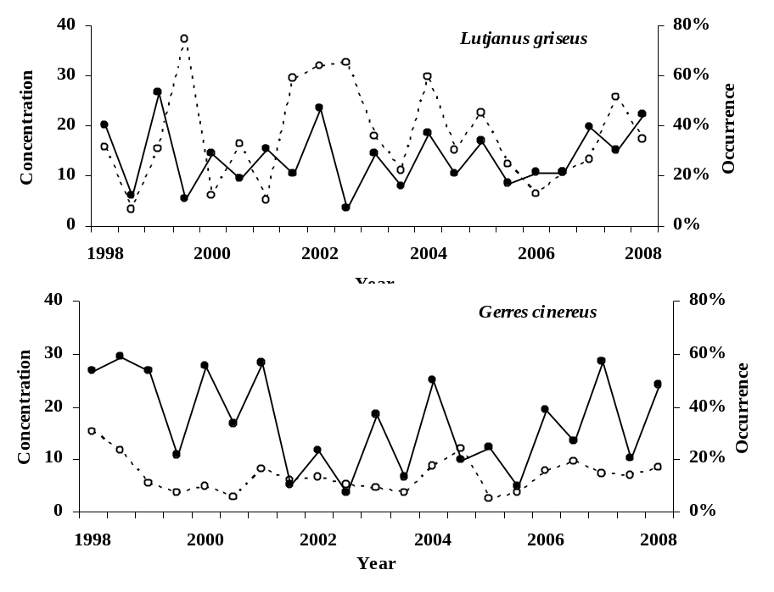

Figure 3: Gray snapper and yellowfin mojarra abundance time series along the mainland stratum. Occurrence and concentration (density when present) values indicated with black and white symbols, respectively.

Habitat suitability models
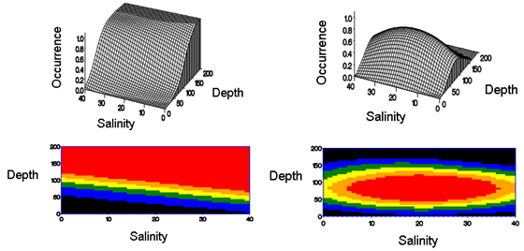
An important objective of the Biscayne Bay Mangrove Fish project is to examine for patterns of fish abundance across salinity gradients to draw inferences about possible impacts of future salinity changes on habitat suitability for individual fish taxa. A variety of regression techniques have been applied to this dataset in this context. Figure 4 presents stepwise logistic regression results for the two species featured above. Until CERP-related changes to salinity fields are implemented, statistical models of this type, coupled with appropriate laboratory studies, offer insights into how a range of different salinity regime scenarios may affect the suitability of shoreline habitats for resident and transient fishes.

Figure 4: Depiction of logistic regression results performed to assess habitat suitability relationships for gray snapper (left) and yellowfin mojarra. Data analyzed were restricted the wet season at sites along mainland stratum. The same response surfaces are depicted in upper 3-D plots and lower contour plots. The color scale in contour plots ranges from low (black) to high (red).

7.5.6 Oysters
7.5.6.1 Oysters – Methods
7.5.6.2 Oysters – Results
7.5.6.3 Oysters – Discussion

7.5.7 Biscayne Bay Alongshore Epifauna
Because of its clear, shallow waters, Biscayne Bay’s benthic community is a primary source of its productivity and diversity. The benthic faunal community, consisting of small forage fish, juvenile game fish, and invertebrates, is particularly well developed in the shallow near-shore zone adjacent to the mainland and may depend on freshwater inflow to the Bay. Many small forage fish such as rainwater killifish, goldspotted killifish, and silver jenny are found more abundantly in the shallow nearshore waters than in the deeper waters of the bay. The commercially important pink shrimp and blue crab also are found in western nearshore Biscayne Bay, where caridean shrimps form another important component of the epifauna. The epifaunal community is a direct food source for gray snapper, spotted seatrout, and great barracuda that frequent the mangrove prop-root zone, where they are monitored by a collaborative project (Serafy et al. 2009). The epifaunal community is an important link in the food web that leads to higher trophic level species such as crocodiles and wading birds. This community will be the first to change when the Biscayne Bay Coastal Wetland Project is implemented. The Biscayne Bay Nearshore Epifauna Project is developing a spatial and temporal characterization of the epifaunal community along the shoreline in order to provide baseline information, community-based performance measures, and restoration targets to use in evaluating CERP alternatives and assessing the effects of CERP implementation.

Shoreline and bottom configuration, vegetation, and salinity patterns are characteristics that define estuarine nursery habitat and faunal communities and determine productive capacity and faunal abundance. The most productive coastal areas are those locations where a favorable salinity range overlaps with favorable shoreline features or, in open water, with favorable bottom configuration and depth. Habitat features such as complexity differ spatially, and greater complexity increases productive capacity by reducing predation, providing a wider variety and abundance of food organisms, reducing physical disturbance, and providing substrates for attachment. The habitat value and productive capacity of many nearshore communities have been diminished by past and current water management practices that have altered the volume, timing, and spatial distribution of freshwater inflow. Habitat value and productive capacity of nearshore areas have declined, partly because of changes in bottom and shoreline vegetation, but largely because salinity zones have shifted and contracted. This has reduced the area of overlap of favorable salinities with favorable types of shoreline and bottom habitat.

This project directly addresses the CERP objective to restore an estuarine faunal community in nearshore waters of western South Biscayne Bay. Requirements for restoration of this community are thought to be a positive salinity gradient distributed broadly along the shoreline, a zone of salinity less than 20 psu throughout the year, and reduced frequency of short-term salinity fluctuations caused by the operation of canal control structures. This project focuses on faunal assemblages as a whole and a suite of the more common species in the shallow open water along the shoreline of South Biscayne Bay. Its purpose is to 1) characterize species assemblages of the wet and dry seasons over the existing spatial range of environmental conditions; 2) identify the species favored by relatively low salinities; and 3) define relationships of potential community-based and species-based indicators with salinity.
7.5.7.1 Biscayne Bay Alongshore Epifauna – Methods
The sampling area is the open water immediately off the western shoreline of Biscayne Bay, from Shoal Point through Manatee Bay. A field study conducted in 2005 and 2006 provided the starting data for the MAP Project, which began in 2007. Four years of data (2005-2008) are available for the area from Shoal Point to Turkey Point, and two years of data (2007-2008) are available for the area from Turkey Point through Manatee Bay (Fig. 7.5.7.1). Two complete collections are made each year, one in the dry season (January-February period) and one in the wet season (July-August period). Sampling is with the 1 m² throw-trap (Robblee et al. 1991, Browder et al. 2005, 2006, Robblee et al. 2008, 2009). Three throw-trap samples are collected at each site. Forty-seven sites were sampled in 2005 and 2006, and 72 sites were sampled in 2007 and 2008. Each site is located in close proximity to a shoreline fish visual survey site (Serafy et al. 2009) in order to facilitate analyses of interactions between shoreline fishes and the epifauna. See Browder et al. (2009) for methods details. Fish and crabs generally were identified to species or at least genus, except for hermit crabs, which were treated as one taxon in summary and analysis. Caridean shrimps also were not identified to species and were treated as one taxon.

[HOT BUTTON TO 20009 ANNUAL REPORT GOES HERE]

[FIGURE 7.5.7.1 (BAYMAPLIKEJOE01.TIFF)] GOES HERE]

Since the objective of CERP is to increase the richness and abundance of species characteristic of estuaries, this project is working toward classifying species as either estuarine or marine to allow species richness to be tracked separately for the two groups. Each species collected has been pre-classified as estuarine or marine based on local references (Gilmore 1996, Serafy and Lorenz 2006) and the on-line database FISHBASE (Froese and Pauly 2008). Classifications according to halo-habitat will be refined and expanded based on analyses described below, including (1) the density-weighted salinity measured at sites where captured, as compared to the average measured salinity across all sites; (2) multidimensional scaling (MDS) plots that portray the relative similarity of spatial distributions among species; and (3) curves of species abundance relative to salinity produced by statistical models.

For each collection, density-weighted salinities were calculated for each species by multiplying salinity by the density at each site, summing the products, and dividing by the total number of individuals of this species in the collection. Resulting values were standardized by subtracting the average salinity measured at the sites. Mean standardized density-weighted salinities were calculated for each species across all collections in which it occurred and 95% confidence limits were placed around the mean.

MDS plots were constructed from the data matrix output as part of the Bray Curtis cluster analysis (McCune and Grace 2002). Original data were 4th-root transformed for entry into the cluster analysis. The original halo-habitat of each species was shown on each plot. Each MDS plot included only a subset of the total species because not all species occurred in a given collection, and not all of these occurred at more than one site. More details are in Browder et al. (2009).

[HOT BUTTON TO 2009 ANNUAL REPORT GOES HERE]

In one statistical modeling approach, the data for each of the more abundant species were divided into 5-psu salinity bins, and linear regression was performed, prescribing a polynomial equation to allow a maximum (i.e., an optimum salinity) to be defined within the range of the data. The three abundance indices—occurrence, concentration, and density—each were plotted relative to salinity and superimposed by the fitted curve of the equation. Finally, statistical models were developed to explore the possible influence of salinity, other aspects of water quality, habitat, and species interactions on the density of individual species. General additive models with forward and backward selection routines were used to determine the significant factors in explaining variation in density for each species, and then these factors were included in corollary multiple regression models with splines. Details of model development were given in Browder et al. (2009).

[HOT BUTTON TO 2009 ANNUAL REPORT GOES HERE]

A “stoplight” approach was used to examine baseline wet and dry season variability of selected Biscayne Bay species, by year, for four segments of shoreline. The shoreline segments were North (north of Black Point), Central (Black Point to Turkey Point), South (Turkey Point to Little Card Sound), and Southern Sounds (Little Card Sound to Manatee Bay). Data for the two seasons were analyzed separately. Eight species were examined in the dry season and seven in the wet season. First, density quartiles (25th, 50th, and 75th) across all years and areas were calculated for each species. Then each segment-year for that species was assigned to a quartile based on its mean value compared to the quartile density that had been determined across all years and all shoreline segments. Results were plotted as yellow (between the 25th and 75th quartiles), green (>= 75th quartile), and red (<= 25th quartile) stoplights (solid colored circles).

Species composition generally is more similar at nearby sites than at sites distant from each other (McCune and Grace 2002); however this might not be the case along a shoreline where point-source discharges interrupt the continuity of salinity patterns. To address CERP’s intent to redirect, across the shoreline broadly, some of the fresh water that now flows into South Biscayne Bay from point-source canals, this project is exploring a potential species-composition-based performance measure that quantifies the geographic distance between sites with similar species composition. Cluster analysis was conducted to form groups of sites with similar species composition; then the average pair-wise geographic distance between sites within the same cluster was calculated. A separate dendrogram was prepared for each collection. Presumably, under the present water management, low discharges as in the dry season, will be reflected in relatively homogeneous species compositions among nearby sites; whereas, high discharges, entering the bay through canals, will disrupt salinity patterns and cause species compositions to differ more widely between nearby sites. Under the changes made by CERP, water flowing across the shoreline broadly will create similar salinity gradients all along the coast and foster similar species compositions are nearby sites. If the within-cluster pair-wise metric is sufficiently related to salinity patterns and sensitive to their change, this metric might make a suitable performance measure for tracking CERP success. Details of the approach were given in Browder et al. (2009).

[HOT BUTTON TO 2009 ANNUAL REPORT].

7.5.7.2 Biscayne Bay Alongshore Epifauna – Results
Salinity at sampling sites 1-47 at the time of collections varied spatially and across years from a low of 15.2 psu to a high of 40 psu during the dry season collections of 2005-2008 and from a low of 4.8 psu to a high of 40.3 psu during the wet season collections of 2005-2008. Average salinity at the time of Dry ‘05 collections (33.7 psu) was higher than during the dry collections of the other 3 years (27.5, 26.1, and 25.3 psu). Spatial variation in salinity was much greater during the wet seasons (CV = 33%, 46%, 29%, and 23%) than during the dry seasons (CV = 11%, 14%, 22%, and 16%). Mean salinity at sampling sites 48-72 was higher than at sites 1-47 during 2007 and 2008.

[HOT BUTTON TO 2009 ANNUAL REPORT].

Our eight collections consisted of 50 identified fish species, six identified crab species, and pink and caridean shrimp. Fewer fish were caught in dry seasons than in wet seasons, 39% vs. 61%. The average number of fish per site per collection at sites 1-72 during 2007 and 2008 was 30 in the dry season and 53 in the wet season. In the 2007 and 2008 collections, the average number of fish caught per site at sites 1-47 was almost twice that at sites 48-72 (61 vs. 32 over all four collections). The most abundant species in collections was the rainwater killifish (Lucania parva), which made up 75% of fish collected at Sites 1-47 and 65% of fish collected at Sites 48-72. The most abundant crab was the blue crab (Callinectes sapidus). Carideans made up the 89.95% of the shrimp collected at Sites 1-47, and 98.29% of the shrimp collected at Sites 48-72. The pink shrimp (Farfantepenaeus duorarum) made up 9.99% of the shrimp collected at Sites 1-47 and 1.42% of collected shrimp at Sites 48-72.

Initial halo-habitat classifications were applied to 65 species (Browder et al. 2009). Our initial halo-habitat classifications for the 65 species were as follows. Fourteen fish, one crab, and one shrimp were classified as estuarine (E), three fish and one shrimp were classified as either polyhaline (P) or ambiguously as estuarine-polyhaline (E-P) or non-estuarine-polyhaline (NE-P). Twenty fish were classified as non-estuarine (NE). Classifications for 13 fish, 12 crabs, and two shrimp were undecided at this point (O), although, according to our simplest criteria, all could be classified as estuarine based only on the criteria we applied to the FISHBASE environmental habitat descriptions. P species were distinguished from E species in the initial classification primarily to facilitate comparison of these species to the E species in analyses. Reclassification of the fish species from O to E is pending confirmation from other sources or results of this and other MAP projects. Further literature search is needed to classify the crabs by their halo-habitat. All species are open to reclassification as our knowledge of the species in South Florida progresses. Preliminary lists with halo-habitat classifications can be seen in Browder et al. (2009).

[HOT BUTTON TO 2009 ANNUAL REPORT]

Figure 7.5.7.2, based on data from sites 1-47 from up to eight collections, 2005-2008, shows the mean and confidence limits of standardized density-weighted salinity for each species over all collections in which the species occurred. Negative density-weighted salinity values indicate that the distribution of a species was centered at less than the average salinity of the sites, whereas positive values indicate that the species’ distribution was centered at greater than the average salinity of the sites. This analysis, as more years of data are incorporated, may help to classify species according to halo-habitat.

[FIGURE 7.5.7.2 GOES HERE]

MDS plots were prepared from a subset of species that occurred at more than one site during any one collection; therefore each MDS plot potentially represented a different set of species. Table 7.5.7.3 shows the species used in the MDS plots overall and the specific ones used in the plot for each collection (i.e., each year-season).

[TABLE 7.5.7.3 GOES HERE]

MDS plots of species based on relative similarity of their spatial distributions indicated a near-central group of two or more species that always (all eight collections) included pink shrimp (Browder et al. 2009) and usually (seven collections) included rainwater killifish, suggesting that their spatial distributions were similar. The consistent central position of pink shrimp and rainwater killifish in the MDS plots, relative to the NE species, which were mainly near the edge of the plots, may have indicated that the distribution of these two species was generally representative of the distributions of the E species. This is not certain, however, because the other designated E species were never all present in the central group—or located together anywhere on the plot, for that matter. All four P species were sometimes in the central group (pink shrimp and goldspotted killifish more frequently than Gulf pipefish and Gulf toadfish). O species that showed up in the central group included caridean shrimp, checkered puffer, code goby, bigeye mojarra, and hermit crab, but only caridean shrimp and the code goby showed up in the central group more than once.

[HOT BUTTON TO 2009 ANNUAL REPORT GOES HERE]

Relationships with salinity were examined for nine taxa: pink shrimp, caridean shrimp, blue crab, goldspotted killifish, code goby, rainwater killifish, clown goby, Gulf toadfish, and Gulf pipefish. Dry season and wet season data were examined separately. The dry season data were assigned to five 5-psu salinity bins, from 16-20 psu to 36-40 psu. The wet season data were assigned to seven salinity bins, from 5-10 psu to 36-40 psu. Assuming significance at p <= 0.1, four occurrence, six concentration, and five delta-density dry-season relationships were significant, and three occurrence, five concentration, and two delta-density wet-season relationships were significant (Browder et al. 2009). Caridean shrimp delta-density displayed a significant increasingly positive relationship with salinity to the limit of the range, 35-40 psu, in both dry and wet seasons. Pink shrimp delta-density had a significant parabolic relationship with salinity (maximum at 30-35 psu) during the dry season, but not the wet season. Blue crab and Gulf toadfish delta-density had significant positive linear relationships with salinity throughout the range during the dry season but not the wet season. Rainwater killifish delta-density had a significant negative linear relationship with salinity throughout the range during the dry season but not the wet season.

[HOT BUTTON TO 2009 ANNUAL REPORT GOES HERE]
.
The GAM-MR approach produced significant models for eight out of nine species for the dry season, missing only code goby, and six out of 10 species in the wet season, leaving out Gulf toadfish, goldspotted killifish, pink shrimp, and hardhead silverside, but including code goby (Browder et al. 2009). During the dry season, salinity, temperature, and Halodule were the most important variables affecting seagrass faunal densities. Wet season faunal densities were driven by water depth, canopy height, Halodule, and salinity.

Significant models also were developed for dry season and wet season fish species richness. Dry season fish richness was related to salinity, temperature, canopy height, predator density (seagrass Opsanus and total mangrove predators). Wet season fish richness was related to salinity, Halodule, number of mangrove predators, distance from the mangrove, and the interaction of predator numbers and distance from the mangroves.

Salinity was an important variable in the models during both seasons, significant in eight of the nine dry-season species models and six of the 10 wet-season models (Browder et al. 2009). In the dry season, four species (blue crab, caridean shrimp, pink shrimp, and Gulf pipefish) were positively correlated with salinity, and three species (clown goby, rainwater killifish, and goldspotted killifish) were negatively correlated with salinity. In the wet season, four species (blue crab, clown goby, rainwater killifish, and goldspotted killifish) were negatively correlated with salinity, and two species (caridean shrimp and gulf toadfish) were positively correlated with salinity. Salinity was a significant variable in explaining fish species richness in both seasons. Species richness was negatively correlated with salinity in the dry season and positively correlated with salinity in the wet season.

[HOT BUTTON TO 2009 ANNUAL REPORT GOES HERE]

Figure 7.5.7.3 shows, in stoplight format, wet and dry season baseline salinities for the seagrass sites by shoreline segment and year. In general, during both seasons, lowest salinities, graded as “green”, occurred in the central shoreline segment and highest salinities, graded as “red” occurred in the two southern shoreline segments. Figure 7.5.7.5 shows the stoplight view of faunal density during the dry season, and Figure 7.5.7.5 shows the stoplight view of faunal density during the dry season. Species differed in their patterns of density, but there were more red signals in the South and Southern Sounds than in the North and Central segments of shoreline and more red signals during the dry season than during the wet season.

[FIGURE 7.5.7.3 GOES HERE]
[FIGURE 7.5.7.4 GOES HERE]
[FIGURE 7.5.7.5 GOES HERE]

In the analysis of pair-wise within-cluster geographic distance between sites, Dry ’05 had the shortest average pair-wise distance, followed by Wet ’07 (Figure 7.5.7.6). A negative linear relationship of pair-wise distance with median or average salinity and positive linear relationship with the spatial variation in salinity (coefficient of variation) were suggested by plots of average pair-wise distance vs. the salinity parameters for each collection, however these relationships, when tested with simple linear regression, were not significant (p>0.1) (Browder et al. 2009).

[FIGURE 7.5.7.6 GOES HERE]
7.5.7.3 Biscayne Bay Alongshore Epifauna – Discussion
This project addresses species abundance and species composition of the epifauna as distributed in open shallow waters along the western shoreline South Biscayne Bay, expected to be the first part of the bay affected by CERP changes in both regional and local water management structures and operations. One project focus is on distinguishing members of the community that have an affinity or reliance on freshwater inflow (i.e., estuarine species) because these species should be followed separately from marine species in documenting changes in species richness after CERP implementation. Building the number of samples that can be used to identify species halo-habitat is expected to increase the reliability of designations arising from this project.

Analytical results from the first four years of sampling are consistent with our expectation that relationships between faunal distributions and salinity can be found in data acquired from sampling the shallow-water nearshore epifauna. Also promising is the potential for finding ecological relationships between mangrove fishes and seagrass fauna.

MDS plots of species based on their spatial distributions (sites 1-47 only) were consistent in showing pink shrimp in the center of the plot, grouped with two or more other species, one or more of which were pre-classified as estuarine, but the plots for each collection were not consistent in showing all or even a substantial portion of species pre-classified as estuarine in the center of the plot. The E species were variously distributed around the plot, but their distance from the central group may have depended on the number of marine (NE) species included in the plot because these plots are based on relative rather than absolute data. Each plot consisted of a slightly different group of species because only those species that occurred in samples from at least two sites in a collection were included in the MDS analysis. Despite these shortcomings, on the basis of the MDS plots at least two of the four P species (pink shrimp and goldspotted killifish) and two of the O species (caridean shrimp and code goby) probably should be classified as E species.

The faunal density-weighted salinities may help to screen species for tendencies toward estuarine or marine habitat, however the confidence limits on most species extend on both sides of the line of neutrality (Figure 7.5.7.2). Furthermore, some species appear to be mis-assigned according to what else know about their ecology. More collections may help to reduce the confidence limits and improve the reliability of these results, making them more useful in refining the classification of species according to halo-habitat.

The combination of general additive modeling and multiple regression modeling with splines produced stronger relationships with salinity for more species than the salinity-bin modeling. Inclusion of other explaining variables may have helped to better define the relationships with salinity.

Examining potential relationships between predator and prey and between epibenthic prey and benthic habitat may be the key to understanding ecological relationships with salinity for both faunal groups. A description of the interrelationships between shoreline fishes, epifauna, and benthic habitat adds another dimension to ecological characterization of the pre-CERP status of the nearshore epifauna in South Biscayne Bay.

The stoplight diagrams prepared with the Biscayne Bay epifauna data was somewhat different from stoplight diagrams that have been prepared in other studies. Usually quartiles of the data have been prepared from one set of years (e.g., historical data) for use in scoring the most recent year (or several recent years). Here, year-shoreline segments were assigned colors based on average salinity in comparison to quartiles prepared from the entire data set, four years of data for two shoreline segments and two years of data for two shoreline segments. Since CERP projects that will affect South Biscayne Bay have not yet entered the construction phase, the Biscayne Bay epifauna stoplights demonstrated the pre-CERP variability in epifauna across time and space in four segments of shoreline before CERP implementation.

Another focus of the Biscayne Bay Nearshore Epifauna project is in quantifying an index of site proximity in relation to species composition. Sites nearest to each other are expected to have the most similar species composition, unless the spatial pattern of factors that influence species composition is disrupted. Results of analysis of eight collections (four dry, four wet) indicated that average pair-wise within cluster geographic distance was significantly shorter (according to 95% confidence limits) for Dry ’05 than for several other collections, wet or dry season. It was anticipated that, under present water management, dry season collections would have shorter pair-wise distances than wet season collections because canal discharges would be less likely to interrupt salinity patterns in the dry season. Although there were no clear dry season-wet season differences, plots of pair-wise distance vs. salinity median, mean, and coefficient of variation (CV) suggested a possible influence of salinity patterns. Pair-wise distance appeared to be negatively related to median salinity (also mean salinity), with pair-wise distance decreasing linearly as salinity increased, and positively related to the coefficient of variation in salinity, increasing linearly as CV increased. It is clearly evident that the distance index varies substantially among collections, and there is some suggestion that the index is sensitive to change in salinity patterns.

These results indicate progress in (1) development of a baseline for characterizing CERP effects in shallow open-water habitat along the South Biscayne Bay shoreline, (2) classification of species based on halo-habitat, (3) determination of relationships of faunal abundance with salinity and other environmental and habitat metrics, (4) development of a performance metric that assesses restoration progress on the basis of similarity of species composition among sites, and (5) the development of a framework for conducting assessments.

    - Fish and Invertebrate Assessment Network

Background and Methods
The fish and invertebrate assessment network (FIAN) project is developing a pre-CERP characterization of seagrass-associated fish, crab and shrimp communities, including the pink shrimp, Farfantepenaeus duorarum. FIAN is organized: 1) in relation to expected upstream hydrologic change with implementation of CERP; 2) on the premise that habitat and environmental conditions, particularly salinity, are critical factors structuring these communities; 3) using the 1-m² throw-trap, a standard approach to quantitatively sampling seagrass-associated fauna (Robblee et al 1991), and 4) to the extent possible situating FIAN monitoring locations where historical data exist. The pink shrimp is a commercially and recreationally important species in south Florida, as well as an ecologically important species in food webs. Southern estuaries provide critical nursery habitat for juvenile pink shrimp. The pink shrimp serves as one of several biological indicator species for assessing the response of South Florida’s southern estuaries to upstream changes in hydrology expected from Greater Everglades restoration (SFWMD 2005; RECOVER 2006; Browder and Robblee 2009).
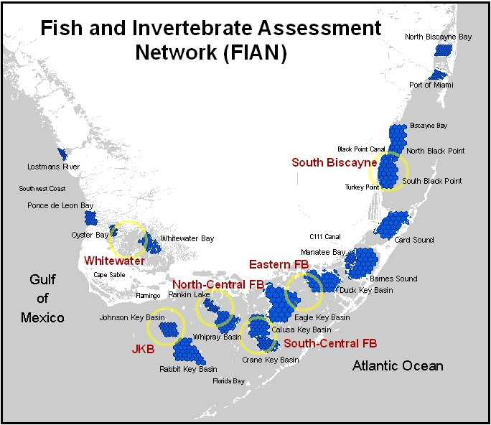
Figure 1. In South Florida, 19 monitoring locations comprise the FIAN network. Each is defined by a 30-cell sampling grid indicated in blue. Open yellow circles encompass monitoring locations aggregated as assessment areas for the pink shrimp performance measure.
Regional in scale (Figure 1), FIAN includes 19 monitoring locations in three South Florida regions; the southwest mangrove coast, Florida Bay, and Biscayne Bay. Sampling in FIAN is conducted twice annually, at the end of the dry season (April/May) and at the end of the wet season (September/October). Starting in 2005, nine consecutive collections, 5 dry and 4 wet season collections, have been completed. Network design and sampling methods are described in detail in Robblee and Browder (2009). Briefly, a 30-cell sampling grid defines each of the 19 monitoring locations (Figure 1). For each season a single randomly located 1-m² throw-trap sample of fish, shrimp, and crabs is collected in each grid-cell for a total of 570 samples in each seasonal collection. Associated with each throw-trap sample are environmental measurements including, salinity, temperature, turbidity, and water and sediment depth, as well as measurements of benthic vegetation including Braun-Blanquet cover/abundance estimates of seagrasses and algae and an estimate of canopy height.

Results and Discussion
The pink shrimp is ubiquitous in south Florida waters (Figure 2). Reported relationships of pink shrimp with salinity suggest that water management affects inshore pink shrimp abundance. Laboratory trials with growth and survival of small juvenile pink shrimp from western Florida Bay were significantly related to salinity (Browder et al. 2002). Indices of pink shrimp abundance based on Tortugas fisheries data were significantly related to indices of freshwater flow from the Everglades (Browder, 1985; Sheridan 1996). Meta-analyses of prominent fauna in Florida Bay found that pink shrimp were more closely correlated with salinity and seagrass than as many as 19 other species examined (Johnson et al. 2002, 2005). Based on the historical record from western Florida Bay, mean fall (September/October) densities of juvenile pink shrimp were significantly negatively correlated with salinity over the range of 28 to 45 (Figure 3).
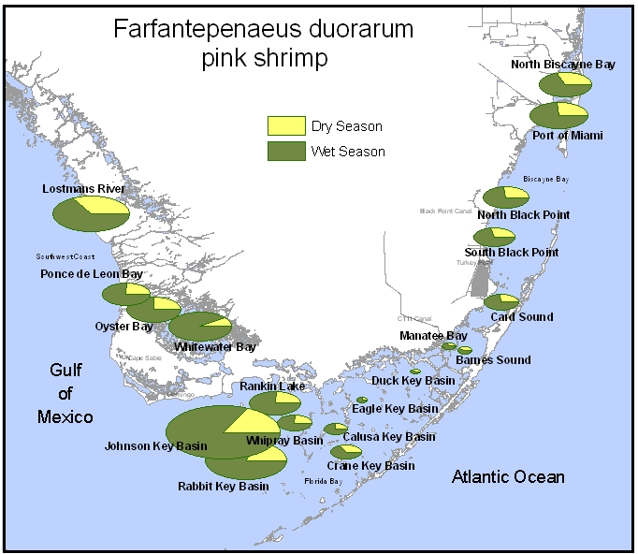
Figure 2. Relative abundance of the pink shrimp in South Florida waters over the 4 years of FIAN, 2005-2009. The size of each pie graph represents the sum of average dry and wet season shrimp density. Shrimp density ranges from a maximum of 7.75 m⁻² at Johnson Key Basin and a minimum of 0.06 m⁻² at Duck Key Basin.
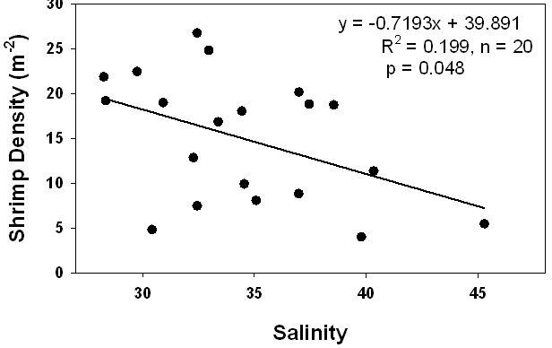
Figure 3. Fall mean juvenile pink shrimp density in western Florida Bay (Johnson Key Basin) in relation to salinity.
Six assessment areas, each encompassing one or more FIAN monitoring locations, provide the spatial context for annually evaluating the status of the pink shrimp in south Florida nearshore waters (Figure 1). At present annual assessment consists of comparison of spring and fall mean shrimp density in relation to available historical data for each area. Thresholds for scoring are based on quartiles of the distribution of available historical data from each assessment area. Values < the 1st quartile are scored as 0 (poor response), values from the 1st to the 3rd quartile are scored as 0.5 (neural response), and values > than the 3rd quartile are scored as 1 (positive response). Long-term 1-m² throw-trap based historical data sets of juvenile pink shrimp density are available for two assessment areas, Johnson Key Basin (n=20) for much of the period 1984 through 2007 and from south Black Point in Biscayne Bay (n=6) for the period 2002 through 2007 (Robblee and Browder 2007). Historical data are limited to 2 to 3 year periods-of-record for the other assessments areas and not considered sufficiently representative of inter-annual variation for reliable comparisons with FIAN estimates of pink shrimp density. The FIAN project is extending the pre-CERP implementation baseline data set for the 19 monitoring locations and the 6 assessment areas.
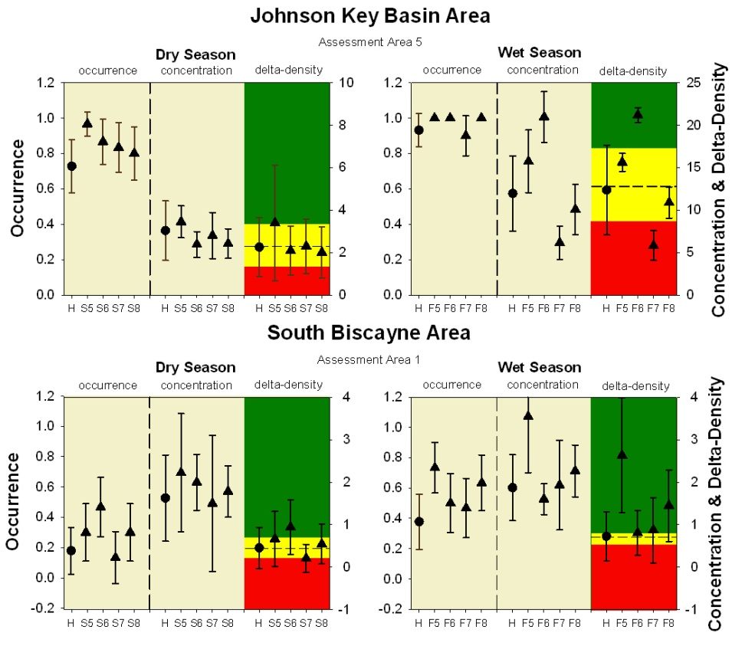
Figure 4. Pink shrimp status over the 4-year FIAN period-of-record (2005-2008) is provided by comparison with historical records of variation in abundance for Johnson Key Basin and south Biscayne Bay. The long-term historical record (H) is indicated with a solid circle ± 95% CI for occurrence (portion of samples positive for pink shrimp), concentration (ln transformed density of shrimp among positive samples only) and delta density (occurrence x concentration). A solid triangle ± 95% CI represents FIAN abundance estimates of pink shrimp for the dry season (S5-S8) and wet season (F5-F8), respectively. The status of pink shrimp is indicated by the overlap of delta-density with the distribution of the historical record: red, <1st quartile (poor), yellow, 1st – 3rd quartile (neutral) and green, > 3rd quartile (positive). See text for explanation of delta- density.
Surveys often produce data that are highly skewed and contain many zeros complicating statistical analyses. This is true in FIAN for the pink shrimp. The proportion of zeros and skewness in the data reflect the underlying pink shrimp distribution (homogeneous to heterogeneous) and ultimately affects the precision of pink shrimp density estimates. In Figure 4 two data sets from the original catch data (historical and FIAN) for JKB and South Biscayne assessment areas were calculated: the proportion of throw-trap samples in which pink shrimp were caught (occurrence), and, the mean density of pink shrimp in samples in which pink shrimp were caught (concentration). The product of occurrence and concentration is delta-density. When the concentration data is natural log-transformed, delta-density is considered to be more representative of the data than a mean density estimate calculated with zero values included.
Table 1. Status of the pink shrimp to date across the four years of FIAN (2005-2008) and each assessment area relative to available historical data. An * indicates assessment areas with limited historical data. Scoring: 0 = poor, 0.5 = neutral and 1 = positive; red, yellow and green, respectively in Figure 4.
Assessment Areas | Spring (Dry Season) |  |  |  |  | Fall (Wet Season)
Assessment Areas | 2005 | 2006 | 2007 | 2008 | mean | 2005 | 2006 | 2007 | 2008 | mean
South Biscayne | 0.5 | 1 | 0 | 0.5 | 0.5 | 1 | 1 | 1 | 1 | 1.0
Eastern FB* | 0 | 0.5 | 0 | 0.5 | 0.1 | 0.5 | 0 | 0 | 0.5 | 0.3
North-Central FB* | 1 | 1 | 0.5 | 0 | 0.6 | 1 | 0 | 0 | 0 | 0.3
South-Central FB* | 0.5 | 0 | 0 | 0 | 0.3 | 0 | 0 | 0 | 0 | 0.0
JKB | 1 | 0.5 | 0.5 | 0.5 | 0.6 | 0.5 | 1 | 0 | 0.5 | 0.5
Whitewater* | 1 | 0.5 | 0 | 0.5 | 0.6 | 0.5 | 0.5 | 0 | 0 | 0.3
mean | 0.7 | 0.6 | 0.17 | 0.42 | 0.5 | 0.6 | 0.4 | 0.17 | 0.33 | 0.4

Relative to available historical data pink shrimp did well in 2005, with average scores among the six assessment areas of 0.7 and 0.6, dry and wet season, respectively. In contrast, 2007 was an extremely poor year with scores among the six response areas averaging only 0.2 and 0.2, respectively (Table 1). On average, 2006 and 2008 were intermediate years. For the four years of FIAN seasonal scoring tracks annual status; mean dry and wet season densities are highest in 2005 while both are lowest in 2007. This pattern also holds for 2006 and 2008, suggesting that pink shrimp status may reflect annual processes rather than just the strength of peak annual recruitment in the fall. In contrast, scoring among assessment areas is highly, variable suggesting the importance of differences in salinity, habitat and postlarval accessibility among them.
Scoring the annual status of the pink shrimp and interpreting patterns in this indicator measure show great promise for furthering our understanding of nursery processes in the southern coatal systems and for assessing responses to Greater Everglades restoration. However, historical data are limited for those assessment areas indicated with an asterisk in Table 1, and caution should be exercised in their interpretation until FIAN extends the pre-CERP time series.

7.5xxx Biscayne Bay Coastal Wetland Fish Communities
[Click here to go to the GE section that has this in it.]

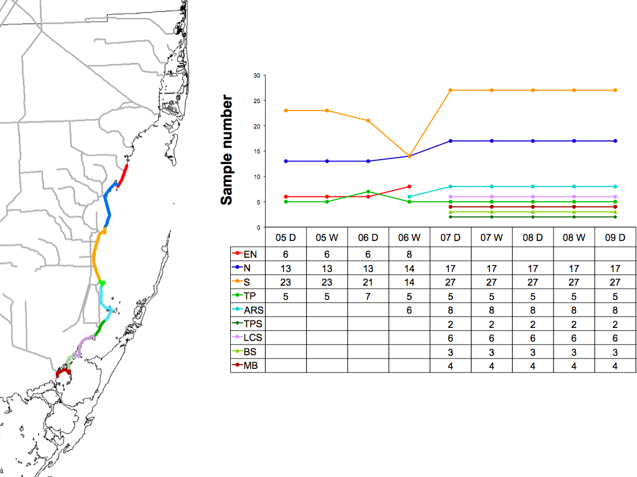

Figure 7.5.7.1 Sampling area and number of samples, by area (down) and collection (across). (Collections are 05 D = 2005 dry season collection, 05 W = 2005 wet season collection, etc.. Areas are EN = extreme north, N=north, S=south, TP=Turkey Point, ARS=Arsenicker, TPS=Turkey Point South, LCS=Little Card Sound, BS=Barnes Sound, and MB=Manatee Bay)
Table 7.5.7.1. Preliminary classification to halo-habitat of fish taxa in collections.

Common name | Scientific name | Classifi-cation for cluster analysis | Gilmore (1995) | Lorenz & Serafy (2006) | L&S category | Fishbase
 |  |  |  |  |  | estuarine | non-estuarine
Atlantic Needlefish | Strongylura marina | E |  |  |  | yes
Bandtail puffer | Sphoeroides spengleri | O |  |  |  | yes
Bay anchovy | Anchoa mitchilli | O |  |  |  | yes
Bigeye mojarra | Eucinostomus havana | O |  |  |  | yes
Blue-striped grunt | Haemulon sciurus | NE |  |  |  |  | yes
Bluethroat pikeblenny | Chaenopsis ocellata | NE |  |  |  |  | yes
Checkered puffer | Sphoeroides testudineus | O |  |  |  | yes
Clown goby | Microgobius gulosus | E | yes |  |  | yes
Code goby | Gobiosoma robustum | O |  |  |  | yes
Crested blenny | Hypleurochilus geminatus | NE |  |  |  |  | yes
Crested goby | Lophogobius cyprinoides | E |  | yes | o | yes
Dusky pipefish | Syngnathus floridae | NE |  |  |  |  | yes
Dwarf seahorse | Hippocampus zosterae | NE |  |  |  |  | yes
Flagfin mojarra | Eucinostomus melanopterus | O |  |  |  | yes
Florida blenny | Chasmodes saburrae | O |  |  |  | yes
Frillfin goby | Bathygobius soporator | E |  |  |  | yes
Fringed pipefish | Anarchopterus criniger | NE |  |  |  |  | yes
Goldspotted killifish | Floridichthys carpio | E-P |  | yes | p | yes
Gulfstream Flounder | Citharichthys arctifrons | NE |  |  |  |  | yes
Gray snapper | Lutjanus griseus | E | yes |  |  | yes
Gulf pipefish | Syngnathus scovelli | P |  |  | p | yes
Gulf toadfish | Opsanus beta | NE-P |  |  | p |  | yes
Hardhead silverside | Atherinomorus stipes | O |  |  |  | yes
Highfin blenny | Lupinoblennius nicholsi | NE |  |  |  |  | yes
Hogchoker | Trinectes maculatus | E | yes |  | m | yes
Jack sp. | Carangidae
Jewel Cichlid | Hemichromis bimaculatus | E |  |  |  | yes
Lined seahorse | Hippocampus erectus | NE |  |  |  |  | yes
Lined sole | Achirus lineatus | O |  |  |  | yes
Longsnout seahorse | Hippocampus reidi | O |  |  |  | yes
Mangrove rivulus | Rivulus marmoratus | E |  |  |  | yes
Northern pipefish | Syngnathus fuscus | O |  |  |  | yes
Pinfish | Lagodon rhomboides | E | yes |  |  | yes
Pugnose pipefish | Bryx dunckeri | NE |  |  |  |  | yes
Rainwater killifish | Lucania parva | E | yes |  | o | yes
Redear Sardine | Harengula humeralis | NE |  |  |  |  | yes
Sailfin molly | Poecilia latipinna | E | yes |  | o | yes
Sailor's choice | Haemulon parra | NE |  |  |  |  | yes
Sargassum pipefish | Syngnathus pelagicus | NE |  |  |  |  | yes
Sheepshead minnow | Cyprinodon variegatus | E | yes |  | o | yes
Silver jenny | Eucinostomus gula | O |  |  |  | yes
Slender mojarra | Eucinostomus jonesi | NE |  |  |  |  | yes
Southern sennet | Sphyraena picudilla | NE |  |  |  |  | yes
Speckled worm eel | Myrophis punctatus | O |  |  |  | yes
Common name | Scientific name | Classifi-  cation  for  cluster  analysis | Gilmore  (1995) | Lorenz  &  Serafy  (2006) | L&S  category | Fishbase
 |  |  |  |  |  | estuarine | non-  esuarine
Spotted dragonet | Diplogrammus pauciradiatus | NE |  |  |  |  | yes
Spotted whiff | Citharichthys macrops | NE |  |  |  |  | yes
Tomtate | Haemulon aurolineatum | NE |  |  |  |  | yes
White grunt | Haemulon plumieri | NE |  |  |  |  | yes
Whitespotted filefish | Cantherhines macrocerus | NE |  |  |  |  | Yes
Yellowfin Mojarra | Gerres cinereus | E |  |  |  | yes

Key to halo-habitat categories cluster analysis: E=estuarine, P=polyhaline, P-E=uncertain whether estuarine or polyhaline, NE-P= uncertain whether marine or polyhaline, O=unclassified
Key to L&S categories: o=oligohaline, p=polyhaline, m=mesohaline

Table 7.5.7.2. Cursory classification of decapod crustaceans in collections based on halo-habitat.

Common name | Scientific name | Classification for cluster analysis
Blue Crab | Callinectes sapidus | E
Common Mud Crab | Panopeus herbstii | O
Common Spider crab | Libinia emarginata | O
Giant Decorator crab | Stenocionops furcata | O
Lesser Blue Crab | Callinectes similis | O
Longspine Swimming Crab | Portunus spinicarpus | O
Marsh Crab sp. | Sesarma sp. | O
Hermit Crab sp. |  | O
Portunus Crab | Portunus sp. | O
Swimming Crab sp. | Callinectes sp. | O
Stone Crab | Mennipe mercinaria | O
Sponge Spider Crab | Macrocoeloma subparallelum | O
Spider Crab sp. |  | O
Common name | Scientific name | Classification for cluster analysis
Pink shrimp | Penaeus duorarum | P
Snapping Shrimp¹ | Alpheus sp. | O
Caridean shrimp | Various, except Alpheus sp. | O
¹The snapping shrimp was counted and otherwise handled separately from the other
caridean shrimp in our samples because of the large size difference.

Key to halo-habitat categories: E=estuarine, P=polyhaline, P-E=uncertain whether estuarine or polyhaline, NE-P=uncertain whether marine or polyhaline, O=unclassified

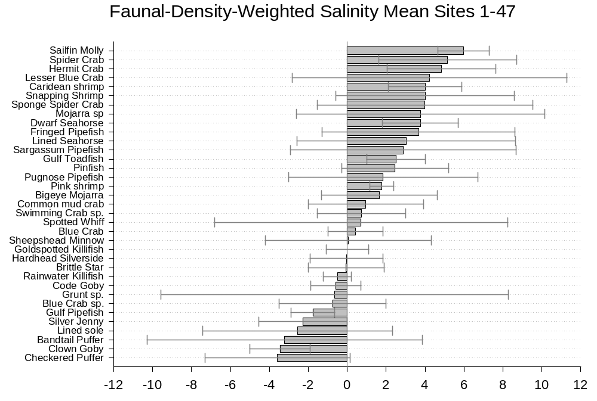
Figure 7.5.7.2. Mean and 95% confidence limits across all collections, wet and dry season, of the standardized faunal density-weighted salinity for each taxa and collection, Sites 1-47, 2005-2008. Standardization was by subtracting, from each density-weighted salinity, the average salinity across sites for that collection. Means and confidence limits are based on from 2 to 8 collections.
Table 7.5.7.3. Species included in the MDS plots, by season-year plot. Higher-order taxa are highlighted and are excluded from the counts at the bottom of the plot if they also are represented by one or more species included in the plot.

Halo-habitat class | Common name | Dry '05 | Dry '06 | Dry '07 | Dry '08 | Wet '05 | Wet '06 | Wet '07 | Wet '08 | Tot
O | Bandtail puffer |  | 1 |  |  |  |  |  |  | 1
O | Bigeye mojarra |  | 1 | 1 | 1 | 1 |  | 1 | 1 | 6
E | Blue crab | 1 | 1 | 1 | 1 | 1 | 1 | 1 | 1 | 8
O | Blue crab sp. |  |  | 1 | 1 |  | 1 |  | 1 | 4
NE | Bluestriped grunt | 1 |  |  |  |  |  |  | 1 | 2
NE | Bluethroat pikeblenny |  |  |  |  | 1 |  |  |  | 1
O | Brittlestar |  |  |  | 1 |  |  |  |  | 1
O | Caridean shrimp | 1 | 1 | 1 | 1 | 1 | 1 | 1 | 1 | 8
O | Checkered puffer |  |  | 1 | 1 |  |  |  | 1 | 3
E | Clown goby | 1 | 1 | 1 | 1 | 1 | 1 | 1 | 1 | 8
O | Code goby | 1 | 1 | 1 | 1 | 1 | 1 | 1 | 1 | 8
E | Crested goby |  |  |  |  |  | 1 | 1 |  | 2
O | Common mud crab | 1 |  |  |  |  |  | 1 |  | 2
NE | Crested blenny |  | 1 |  |  |  |  |  |  | 1
NE | Dusky pipefish | 1 |  |  |  |  |  |  |  | 1
NE | Dwarf seahorse |  |  |  | 1 |  | 1 |  |  | 2
O | Flagfin mojarra |  |  |  |  | 1 | 1 |  |  | 2
NE | Fringed pipefish |  |  | 1 |  |  |  |  | 1 | 2
O | Goby sp. |  |  |  | 1 |  |  |  |  | 1
E-P | Goldspotted killifish | 1 | 1 | 1 | 1 | 1 | 1 | 1 | 1 | 8
E | Gray snapper | 1 |  |  |  | 1 |  |  |  | 2
O | Grunt sp. |  |  |  | 1 |  | 1 |  |  | 2
P | Gulf pipefish | 1 | 1 | 1 | 1 | 1 | 1 | 1 | 1 | 8
NE-P | Gulf toadfish | 1 | 1 | 1 | 1 | 1 | 1 | 1 | 1 | 8
O | Hardhead silverside |  | 1 | 1 | 1 | 1 | 1 | 1 | 1 | 7
O | Hermit crab | 1 |  |  | 1 | 1 |  | 1 | 1 | 5
NE | Highfin blenny |  |  |  |  | 1 |  |  |  | 1
O | Killifish sp. |  |  |  |  |  |  | 1 |  | 1
O | Lesser blue crab | 1 |  |  |  |  |  |  | 1 | 2
NE | Lined seahorse | 1 |  |  |  | 1 |  |  |  | 2

Table 7.5.7.3. Continued.

Halo-habitat class | Common name | Dry '05 | Dry '06 | Dry '07 | Dry '08 | Wet '05 | Wet '06 | Wet '07 | Wet '08 | Tot
O | Lined sole |  |  |  | 1 |  |  |  |  | 1
O | Mojarra sp. |  |  | 1 | 1 |  |  |  |  | 2
O | Needlefish sp. |  |  |  |  |  | 1 |  |  | 1
E | Pinfish | 1 | 1 |  |  | 1 | 1 | 1 | 1 | 6
P | Pink shrimp | 1 | 1 | 1 | 1 | 1 | 1 | 1 | 1 | 8
NE | Pugnose pipefish | 1 |  |  |  |  |  |  |  | 1
NE | Pugnose pipefish |  | 1 | 1 |  | 1 |  |  |  | 3
O | Pipefish sp. |  |  |  | 1 |  |  |  |  | 1
E | Rainwater killifish | 1 | 1 | 1 | 1 | 1 | 1 | 1 | 1 | 8
NE | Sargassum pipefish |  |  |  | 1 |  |  |  |  | 1
O | Sea star sp. |  |  |  |  |  |  |  | 1 | 1
E | Sheepshead minnow |  | 1 | 1 | 1 | 1 | 1 | 1 | 1 | 7
O | Silver jenny | 1 | 1 | 1 |  | 1 | 1 |  | 1 | 6
NE | Slender mojarra |  | 1 |  |  |  |  |  |  | 1
O | Snapping shrimp |  | 1 |  |  |  |  |  |  | 1
O | Spider crab |  |  |  |  | 1 |  |  |  | 1
O | Speckled worm eel |  |  |  |  | 1 |  |  |  | 1
O | Sponge spider crab | 1 | 1 |  |  |  | 1 |  |  | 3
NE | Spotted whiff | 1 | 1 |  |  |  |  |  |  | 2
O | Swimming crab |  | 1 |  |  | 1 | 1 |  |  | 3
NE | Tomtate |  | 1 |  |  |  |  |  |  | 1
NE | White grunt |  |  |  |  | 1 |  |  |  | 1
NE | Whitespotted filefish | 1 |  |  |  |  |  |  |  | 1
E | Yellowfin mojarra |  |  |  | 1 |  |  |  |  | 1
O | Unidentified fish |  |  |  | 1 |  |  |  |  | 1
Species |  | 22 | 23 | 18 | 25 | 25 | 21 | 17 | 21
Taxa already represented |  | 0 | 0 | 2 | 5 | 0 | 3 | 1 | 2
Total species represented |  | 22 | 23 | 16 | 20 | 25 | 18 | 16 | 19

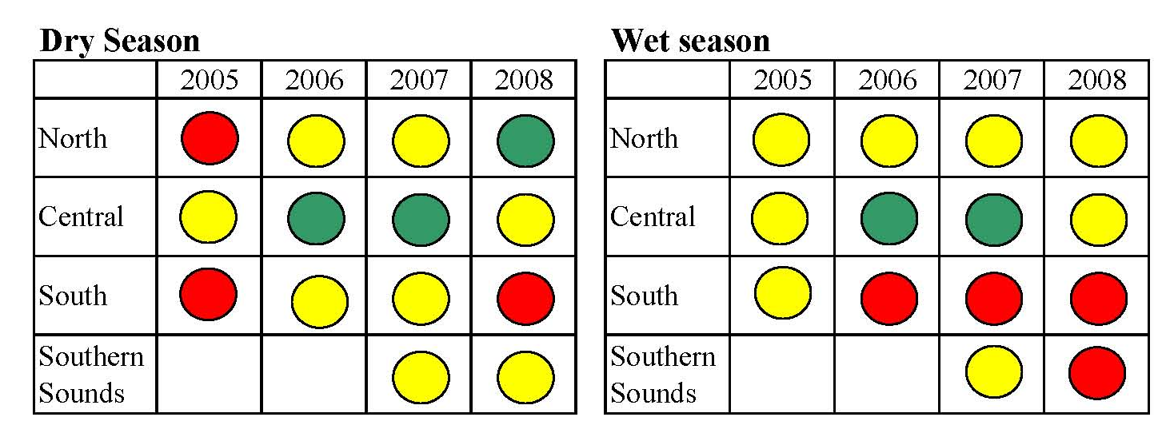

Figure 7.5.7.3. Stop-light scores of salinity, by shoreline segment, year, and season (dry or wet season collection). Quartiles were determined from all 14 data points, then each year-shoreline segment was assigned a stoplight color based on whether its mean lay between the 25th and 75th quartiles (yellow), below the 25th quartile (red), or above the 75th quartile (green).

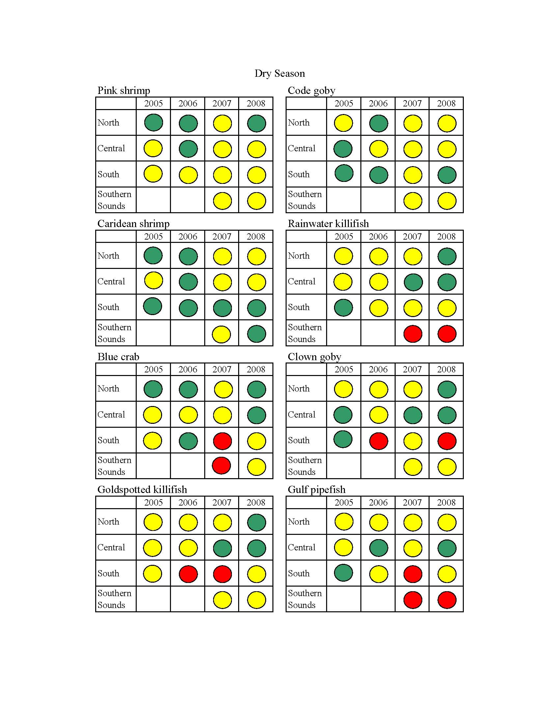

Figure 7.5.7.4. Dry-season stop-light scores of faunal density for each of eight species, by shoreline segment and year. Quartiles were determined from all 14 data points for the season, then each year-shoreline segment was assigned a stoplight color based on whether its mean faunal density lay between the 25th and 75th quartiles (yellow), below the 25th quartile (red), or above the 75th quartile (green).
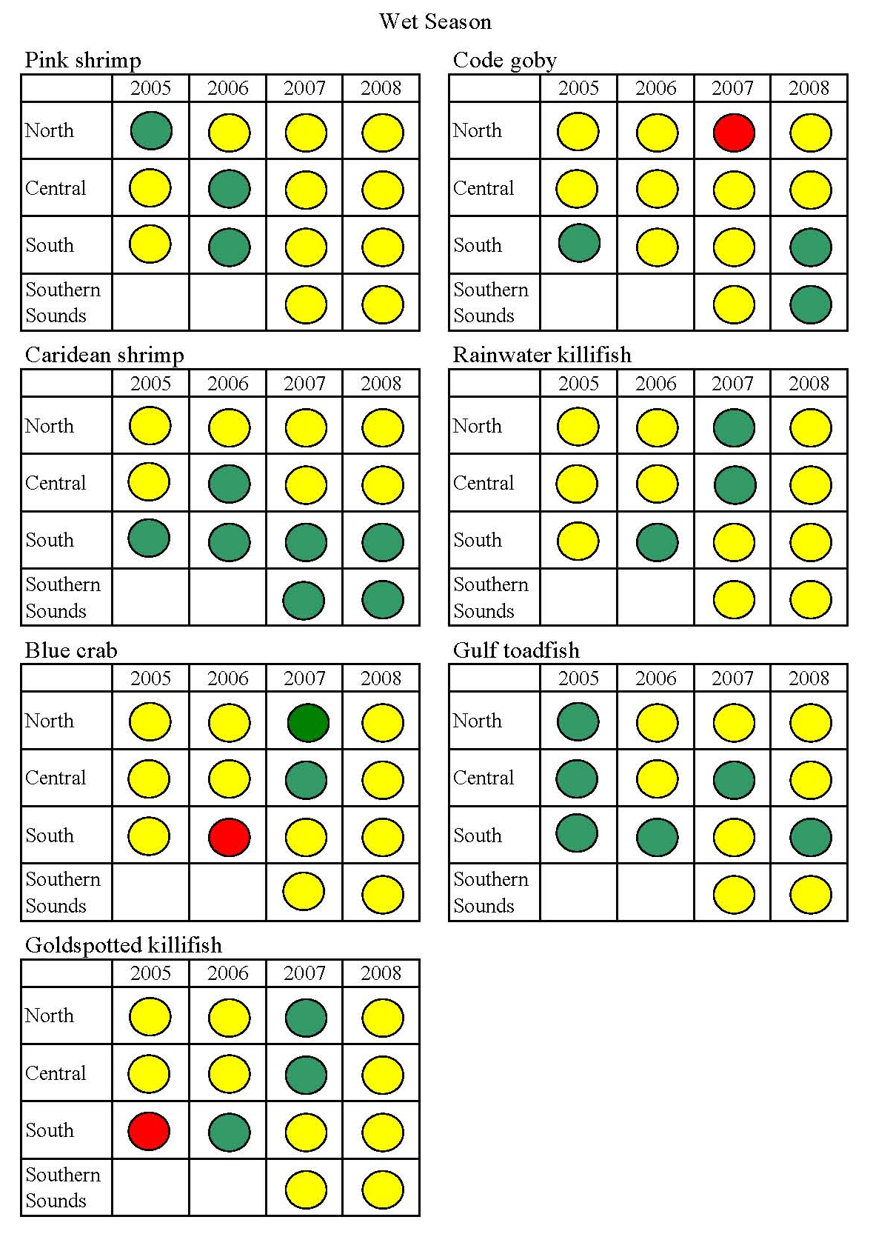
Figure 7.5.7.5. Wet-season stop-light scores of faunal density for each of seven species, by shoreline segment, year, and season (dry or wet season collection). Quartiles were determined from all 14 data points, then each year-shoreline segment was assigned a stoplight color based on whether its mean lay between the 25th and 75th quartiles (yellow), below the 25th quartile (red), or above the 75th quartile (green).

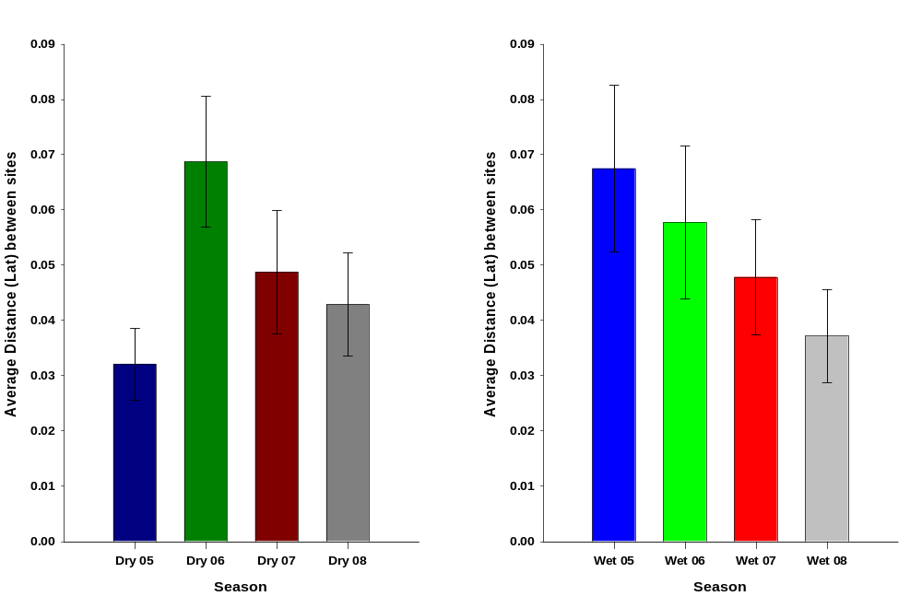

Figure 7.5.7.6. Average pair-wise within-cluster geographic distance between sites, with 95% confidence intervals.

